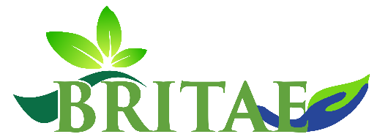
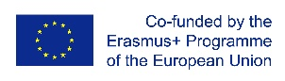

Building Resilience in Tropical Agro-Ecosystems (BRITAE)

Project No: 610012-EPP-1-2019-1-LK-EPPKA2-CBHE-JP

Project is funded by: Erasmus+ Capacity Building in the Field of Higher Education Programme

Duration: 2020-2023

The objective of the project – to develop the joint curricula modules on building resilience in tropical agro ecosystem (BRITAE) in Sri Lankan universities in order to increase their capacity to continually modernize, enhance the quality and relevance of education of students to the global market needs and to ensure international cooperation in line with the above needs.
Main objectives of MICROBE project:
- To understand the knowledge gaps in agroecosystem based resilience through a comprehensive survey framework by assessing the knowledge gaps, resources, capacities of current agroecosystem based resilience for joint curriculum development.
- To develop a joint innovative and adaptive MSc curriculum on tropical agroecosystem based resilience aiming at food security and climate change impacts.
- To develop a Smart Agroecosystem based Resilience Center for teaching, learning, research, and development.
- To develop and implement an online student service platform by blending European practices in education (learning and teaching tools, methodologies and didactic approaches including learning outcomes and ICT-based practices) from participating EU universities to program country universities.
- To implement Master's degree programme in Building Resilience in Tropical Agroecosystems
- To prepare academic and administrative staff in the HEIs to undertake advanced, world-class and innovative, multi- and inter-disciplinary research that will contribute to increased ecological resilience to disasters by providing robust understanding on climate change, and DRR activities focused more on agroecosystems.
- To increase international cooperation by partner HEIs on research programmes that tackle ways to increase societal resilience to disasters.
- To reinforce educational and scientific networking among EU and PC universities in the BRITAE.
- To disseminate the project progress, successes and outcomes as far as possible, and raising awareness across the field of HE about capacity building for research area- resilience building on agro-ecosystems.

The main results and impact envisaged will be achieved as follows:
- development platform to apply high impact research experiences from EU countries to embed in developing countries of the Asia region jointly by the academic Institutions;

Coordinator: University of Ruhuna (Sri Lanka)

Project partners:

Vilnius Gediminas Technical University (Lithuania)  University of Colombo (Sri Lanka)  University of Moratuwa (Sri Lanka)  University of Sri Jayewardenepura (Sri Lanka) | Sabaragamuwa University of Sri Lanka (Sri Lanka) University of Huddersfield (UK)  University of Lancashire (UK)  Tallinn University of Technology (Estonia)

Project contact person in VGTU: Prof. Arturas Kaklauskas, Project Manager, Head of the Department of Construction Management and Real Estate, arturas.kaklauskas@vilniustech.lt

